|  |  |
| --- | --- |
| 0 | Alloc 4 |
| 1 | Read |
| 2 | Store 0 |
| 3 | Read |
| 4 | Store 1 |
| 5 | Const 0 |
| 6 | Store 2 |
| 7 | Load 0 |
| 8 | Load 1 |
| 9 | Less |
| 10 | Fjump A |
| 11 | Load 1 |
| 12 | Load 0 |
| 13 | Add |
| 14 | Store 1 |
| 15 | Load 1 |
| 16 | Load 0 |
| 17 | Sub |
| 18 | Store 0 |
| 19 | Load 1 |
| 20 | Load 0 |
| 21 | Div |
| 22 | Store 1 |
| 23 | **A:** Load 3 |
| 24 | Load 1 |
| 25 | Leq |
| 26 | Fjump B |
| 27 | Load 1 |
| 28 | Load 3 |
| 29 | Mod |
| 30 | Const 0 |
| 31 | Eq |
| 32 | Fjump C |
| 33 | Load 2 |
| 34 | Const 1 |
| 35 | Add |
| 36 | Store 2 |
| 37 | Load 3 |
| 38 | Const 1 |
| 39 | Add |
| 40 | Store 3 |
| 41 | **C:** load 3 |
| 42 | Const 5 |
| 43 | Mul |
| 44 | Store 3 |
| 45 | Jump A |
| 46 | B: load 2 |
| 47 | Write |
| 48 | Halt |

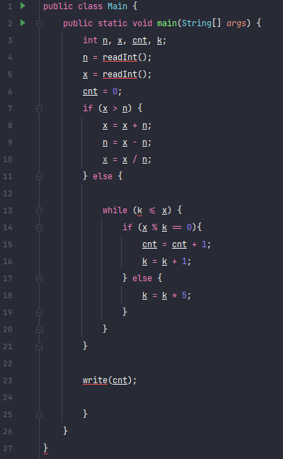

Blocks: A-23, B-46, C-41

Variables: n-0, x-1, cnt-2, k-3